Events Magazine (September 3rd to October 8th 2009)

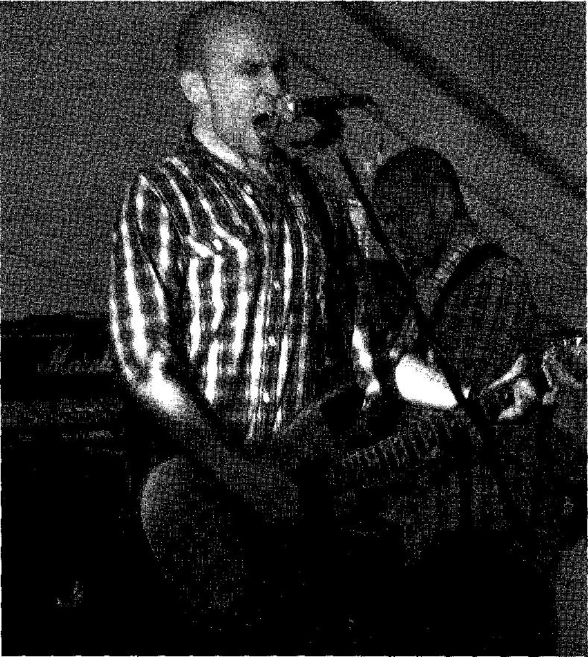
A full-throttle performance from Willie Campbell and Our Small Capital at Sounds in the
Grounds

It was yet another step forward and another step up for the ever expanding and evolving Sounds in the Grounds Festival, an event that in four short years has gone from a local music scene happening, staged on the back of an articulated lorry trailer to hosting world class Scottish Pop-Rock acts the Hazey Janes and Malcolm Middleton. With a much larger Main Stage marquee and the addition of a second, more intimate acoustic stage being added to this years programme - the organisers, the Western Isles Nu-music Trust still managed to maintain that endearing essence of being a very personable, cozy, chilled-out, come-one-come-all, family orientated, community spirited, day out on the Castle Green.... And after a big pre-event spread in the Highland News and a "wish i could be there" shout out from top taste-maker and BBC Radiol presenter DJ Vic Galloway; there was already a good bit of hype that had to be lived up to.... But, on the day, every single band, performer, technician, etc... was spot on and delivered big stylie!!!

The general across the board consensus seems to be that the day was a resounding success with The Hazey Janes and The Avante Gaelic Obscurist Folk Rock orchestra/supergroup (go to youtube to check out the video of their song 'Airidhbhruach' from their Sounds in the Grounds set) being amongst the countless highlights and crowd favourites that will be talked about for weeks to come.

http://www.hebevents.com

